Irfan Ahmed
ICP 10
Due Date: 11/3/2020
  - What you learned in the ICP
For this ICP the goal was to design a Deep Q learning Network (DNQ) using Keras & OpenAI Gym, for cartpole game. The basic idea behind reinforcement learning is that it receives feedback in the form of rewards. The agent’s utility is defined by the reward function and learn to maximize the expected rewards. The learning is based on the outcomes from the observed samples. The Cartpole environment is composed of observations, reward, and action. The observation consists of an array containing 4 float values. It has the cart velocity, angular position, and velocity of the pole. The reward is scalar float values consisting of 0 and 1’s. The 0 means move to the left and 1 means move to the right. This is just basic outline what I learned in the process while working on the ICP.
  - ICP description what was the task you were performing
- Imported the required libraries
- created environment using gym.make for Cartpole-v0. Looked at the observation state amd action state
- Actual environment setup and rendered the results
- Setup the parameters like episodes, explorations rate, memory size, learning size, memory, etc..
- Build model using keras. Model = Sequential ()
- Created functions for memory, exploration rate, preprocess to determine the format is in the right format, relay function, and run function.
  - Challenges that you faced
This ICP was more difficult than I thought it would be. There is lot of information on the internet, but it was very difficult to determine where I should begin. I had difficulty in putting the model and training together and figuring out how to display the visualization on my screen. Encountered lot of confusion why certain parameters were used, and how to train the data before applying it to my model. At the end add the most difficult time running my model on the screen.

  - Screen shots that shows the successful execution of each required step of your code

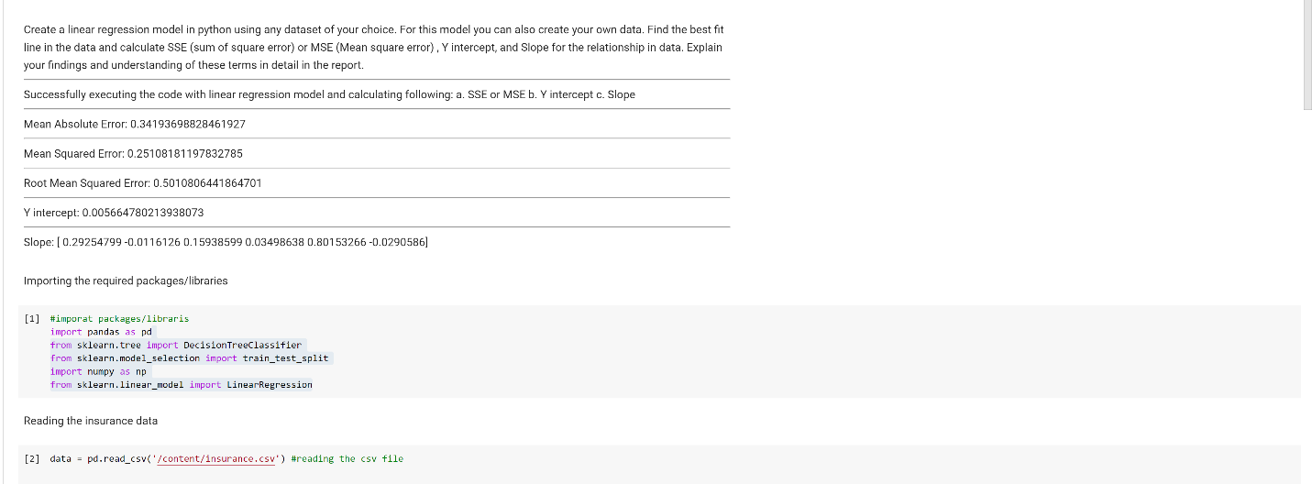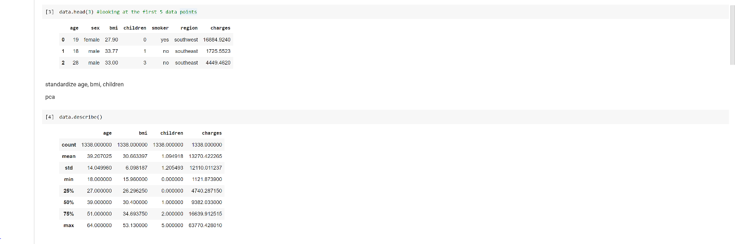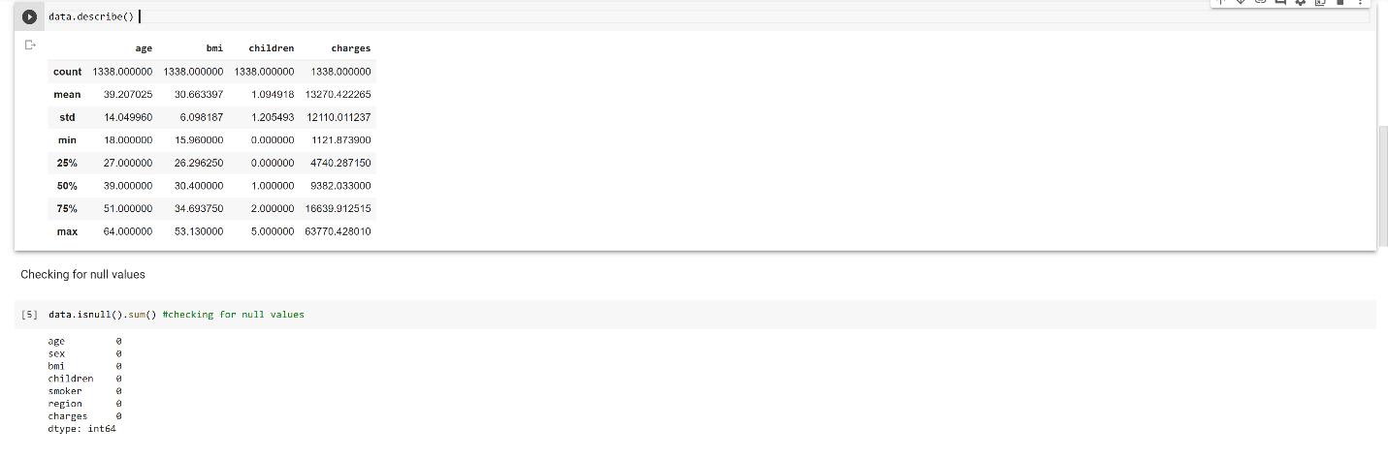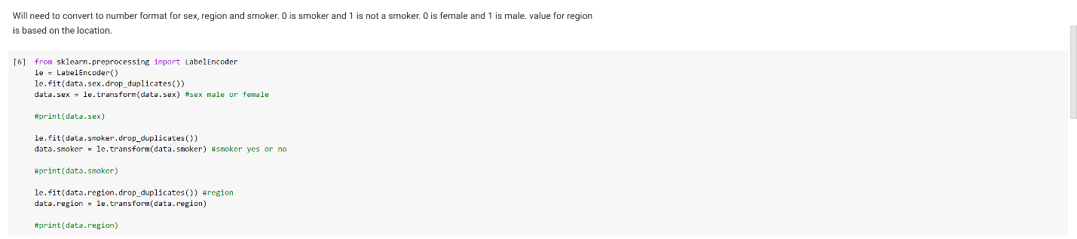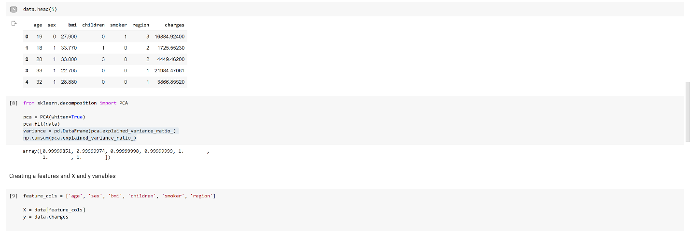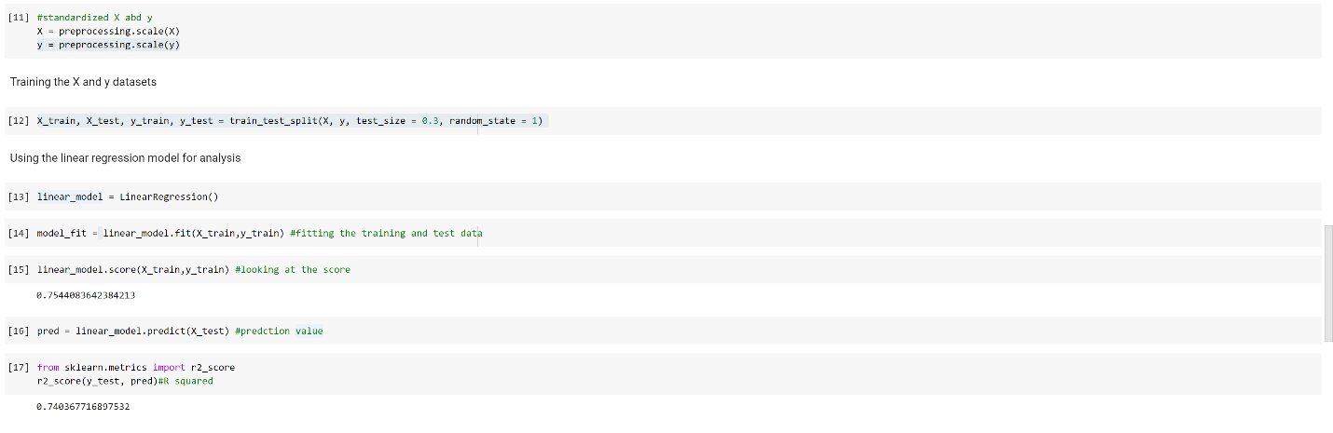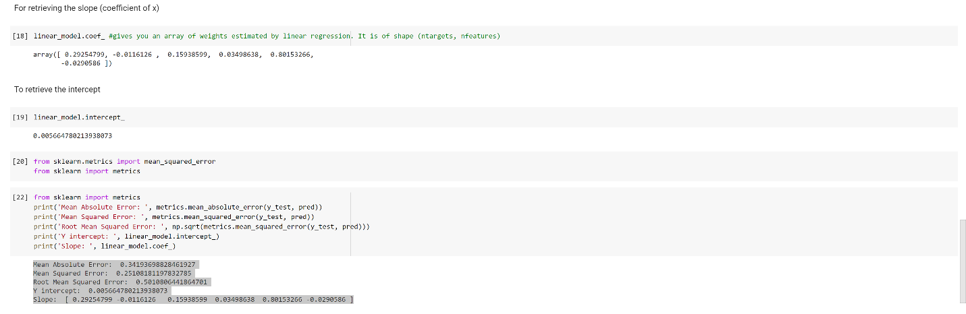

  - Output file link if applicable
https://github.com/UMKC-APL-BigDataAnalytics/icp10-irfancheemaa
  - Video link (YouTube or any other publicly available video platform)
https://umkc.hosted.panopto.com/Panopto/Pages/Viewer.aspx?id=6368a223-639e-4770-ad23-ac69000e5bf9
  - Any inside about the data or the ICP in general
I enjoyed the concept, but it was a bit difficult to run most of the stuff in google colab. I think a small outline would have been nice to follow and get an idea how the structure the code.

